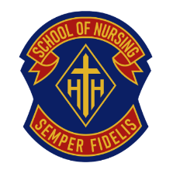
2026 MEMBERSHIP RENEWAL FORM

Your Holy Cross School of Nursing Alumni membership is now due.
Fees are $20.00 per year for the period January to December.
THE ANNUAL MEMBERSHIP IS THE ALUMNI’S ONLY SOURCE OF FUNDING

Return Membership form and payment ($20.00) by cheque
Payable to “HOLY CROSS ALUMNI” to:

Patricia Jeffery (Jensen ‘78)
131 Sunmeadows Crescent SE
Calgary, AB T2X 3H1

You can also e-transfer your payment to president.hxh@gmail.com
Just make sure to include the following contact information in the MESSAGE portion at the bottom of your e-transfer.

If paying for your membership and the September banquet, you may combine both payments into one cheque or e-transfer.

Name______________________________________________________ Maiden Name_______________________________________________
Year of Graduation___________ Address____________________________________________________ City__________________________ Province/State________________
Postal Code/ Zip code____________ Phone_______________________

If you wish to receive the NEWSLETTER by EMAIL, please provide your EMAIL address:________________________________________________

COMMENTS: _______________________________________________________________________________________________________________________________________________________________________________________

If you have any questions, Pat can be reached at 403-830-7735

